1. Теперь слегка похоже на драфт статьи. Я переписал введение, заключение, много правил без треков остальные части, Дима тоже. Ненужные замечания убрал, оставил только нужные в тексте.
2. Статистическая часть. Используй только непереметрический тест PERMANOVA, так как при данной выборке даже тест на нормальность не гарантия нормального распределения. Результаты не должны измениться принципиально насколько я вижу. Далее, RDA PCA напиши максимально чётко, особенно методы. Очень серьёзный мат0ематик, который использовал эти методы, до конца не понял что ты имела в виду.
3. Абстракт напиши сама, журнал Diversity (Basel)/ Используй Conclusion.

IS GENETIC INTEGRITY THROUGH THE DISTANT OCEAN BASINS POSSIBLE? A CASE STUDY OF THE MESOPELAGIC SHRIMP *SYSTELLASPIS DEBILIS.*

1. **Introduction**

The oceans cover the majority of the Earth’s surface area and habitat volume; the vast deep-pelagic habitat between the sunlit layers (upper 200 m) and the seafloor is the largest and least-understood environment on our planet (Webb et al., 2010; Sutton et al., 2017). This habitat contains the mesopelagic (from 200 m to ca.1000 m depth) and deeper bathy- and abyssopelagic. Our limited knowledge of these ecosystems is increasingly problematic as they may be vulnerable to global issues such as climate warming, deoxygenation, acidification, commercial fishing, seabed mining, and other threats with unknown potential for feedback to the climate system (e.g., Sarmiento et al., 2004; Mengerink et al., 2014). Albeit greatly underexplored, the mesopelagic provides a better chance for ecosystem analyses than deeper layers that require even more time- and cost-consuming efforts. Recent analyses based mainly on an expert opinion on the distributional patterns of pelagic fauna relative to environmental proxies allowed a global biogeographic classification of the mesopelagic zone (Sutton et al., 2017). The same authors declared that “work remains to be done to produce a comprehensive and robust mesopelagic biogeography” and this work should be based on numerous empirical observations on the factors driving biodiversity of individual species within the mesopelagic zone. The main attention should be paid to zooplankton that is the key element in the mesopelagic because they are the basic trophic link primary producers with larger predator, abundant enough to be representatively sampled (e.g., Mackas & Beaugrand, 2010; Vereshchaka et al., 2023GEB).

Recent studies based on morphological approach to biodiversity showed that abiotic factors such as circulation including subtropical ocean gyres (Palumbi, 1994; Norton and Goetze, 2013; Kulagin et al., 2014; Deagle et al., 2015; Timm et al., 2020; Burridge et al., 2015), oceanographic gradients (Miyamoto et al., 2010; Yebra et al., 2011; Kulagin et al., 2021), and continental land masses (Palumbi, 1994; Blanco-Bercial et al., 2011; Churchill et al., 2014; Andrews et al., 2014) greatly contribute to biodiversity of mesopelagic plankton. Biological factors including population density (Goetze et al., 2017; Kulagin and Neretina, 2017; Choo et al., 2021), or behavior (Timm et al., 2020) may also drive biogeographic structure of populations.

Studies on the genetic diversity is one of finer and promising tools for a deeper insight into mesopelagic biogeography; this tool, however, has been so far applied to a limited number of zooplankton species and showed that patterns of genetic structuring of populations are species-specific (Churchill et al., 2014; Bucklin et al., 2018). In other words, we need much more research on individual species before the proper understanding drivers of the true (genetic morphological) biodiversity of the mesopelagic.

In this paper we make the next, one among many, step in this direction and focus on the population structure of a cosmopolitan species *Systellaspis debilis* (A. Milne-Edwards, 1881) that makes a significant contribution to mesopelagic ecosystems (Burukovsky, 1992)andis the fourth most common pelagic shrimp in the Atlantic (Judkins, 2014). In contrast to previous studies of mesoplankton, this is a macroplankton Decapoda, a group still unexplored in this context in spite of their prominent role in the mesopelagic zone (40% of the total mesopelagic plankton biomass: Vereshchaka et al., 2017). *Systellaspis debilis* occurs in many mesopelagic biogeographical provinces sensu Sutton et al. (2017) in the Atlantic, Indian, and Pacific Oceans from 63°N to 58°S (Iwasaki, Nemoto et al., 1987). Such an extensive range of species always raises questions about its genetic homogeneity and population structure. In this paper we describe and analyze genetic and morphological diversity of *S. debilis* in order to assess the degree of isolation between populations from various basins. Due to high requirements to the material to analyze (undamaged specimens for morphological analyzes, “fresh” alcohol-fixed individual for genetic analyses) our studies are restricted to the North Atlantic, South Atlantic, and the South-west part of the Indian Ocean.

We test the hypothesis that populations of *S. debilis* are genetically and morphologically distinct in these three ocean basins and analyze the accordance of their geographic distribution with the proposed scheme of mesopelagic zonation (Sutton et al., 2017). In order to test our assumption, we assessed the distribution of genetic and morphological variability in *S. debilis* populations across the Atlantic and South-West Indian Oceans. We sequenced the mitochondrial cytochrome c oxidase I gene (COI) in 75 specimens, the nuclear internal transcribed spacer 1 (ITS1) gene in 23 specimens, and scored 32 morphological characters in 73 specimens.

**2. Materials and methods**

**2.1. Sampling.**

The material was collected in the Atlantic Ocean and the southwestern part of the Indian Ocean during Cruises in 2013th-2020th (Fig. 1 and Table 1 in the Appendices) with a Bogorov-Rass plankton net (mouth area 1 m2, 500 μm mesh size) and an Isaacs-Kidd midwater trawl (mouth area 5.5 m2, mesh size 5 mm). A total of 75 samples of *S. debilis* were identified using the key of Lunina et al. (2019), fixed in 96% ethanol just after retrieval, and stored at -20°C in the laboratory for further analysis.

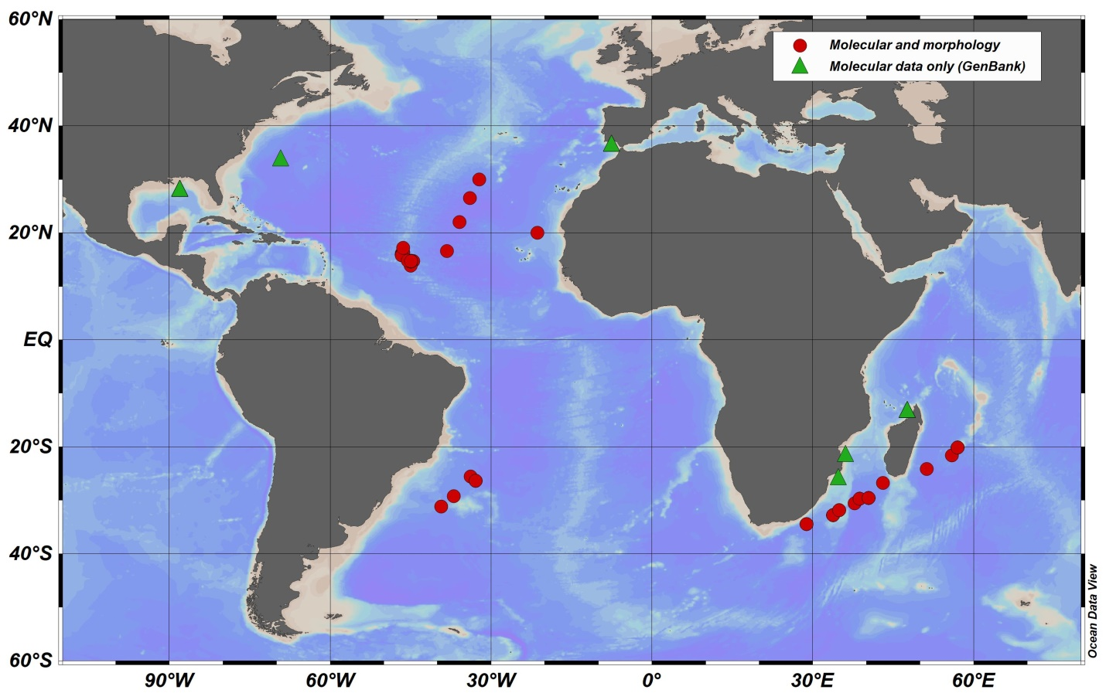

Figure 1. Sampling locations of *Systellaspis debilis* in the Atlantic and Indian Oceans and their basin-scale grouping. Symbols indicate the type of data that were obtained (see legend on the map). Оконтурьте на карте три региона.

**2.2. DNA extraction, amplification, and sequencing**

DNA was isolated either from the fifth pair of the pleopods or from the pleonic muscle tissue using the IG-Spin™ DNA Prep 200 kit for DNA extraction following the manufacturer’s protocol. The isolated DNA was used as a matrix for the amplification of the mitochondrial cytochrome *c* oxidase subunit I gene fragment I (COI), and the nuclear gene of the first internal transcribed spacer (ITS1). PCR amplification of the COI gene fragment was accomplished with the universal primers LCOI 1490 (GGTCAACAAATCATAAAGATATTGG) and HCOI 2198 (TAAACTTCAGGGTGARDAAAAAATCA) (Folmer et al., 1994) or decapod-specific primers COL6 (5’-ACAAATCATAAAGATATYGG-3’) and COH6 (5’-TADACTTCDGGRTGDRDAAARAAYCA-3’) (Schubart et al, 2006) in cases where the former failed. The primers ITS1FW (5'-CACACCGCCCGTCGCTACTA-3') and ITS3R (5′-TCGACSCACGAGCCRAGTGATC-3′) (Wormhoudt et al, 2019) were used to amplify the ITS1 gene. PCR reactions were made in a reaction volume of 20 μl, containing 2.4 μl of the Encyclo Plus PCR kit (Eurogen, Russia), 0.2 μl of each primer, 1.6 μl of DNA template, 15.3 μl MilliQ water, and 0.3 μl of 50X Encyclo polymerase (Eurogen, Russia). The PCR cycling profiles and annealing temperatures are listed in the Appendices Table 2. The PCR products were purified and sequenced with the same primer sets on an ABI Prism 3500 xl genetic analyzer in the Resource Center Development of Molecular and Cellular Technologies of Saint Petersburg State University. Forward and reverse COI and ITS1 sequences were assembled in Geneious® 7.1.3. and manually treated for ambiguities and heterozygotes (in the case of ITS1). Also, COI sequences were checked for stop codons using Geneious® 7.1.3 software. All sequences were deposited in the NCBI GenBank database (Benson et al., 2012) (Table 1 in the Appendices; accession numbers: XX-XX)

**2.3. Sequence alignment and phylogenetic analyses**

For the genetic analysis, all available COI sequences of *S. debilis* and the most closely related species *S. liui* (no. KT946751) were taken from GenBank (<https://www.ncbi.nlm.nih.gov/genbank/>) in order to complete the dataset. Two species of the superfamily Oplophoroidea, *S.curvispina* (no. KP076159) and *Acanthephyra quadrispinosa* (no. KP076178), were chosen as outgroups to root the tree. Multiple alignments of all sequences were made in Geneious® 7.1.3 using the MUSCLE algorithm (Edgar, 2004) (25 repeats). The final alignment for the COI fragment was 539 bp and included 109 sequences, and for the ITS1 fragment, 23 sequences of 328 bp. In the case of the ITS1 gene, the sequences were not found in public sources, so only newly generated sequences were analyzed.

Phylogenetic reconstruction of the COI gene by the Maximum likelihood (ML) was run with the RAxML (ver. 7.2.8 (Stamatakis, 2006)) using the GTR+G nucleotide substitution model for each codon position. Statistical support was assessed using the bootstrap method involving 1000 replicates. Bootstrap values greater than 70% were considered statistically significant. Before the Bayesian analysis was run on the COI dataset, most appropriate nucleotide substitution models and partitioning scheme were selected for each codon with the use of the Akaike Information Criterion (AICc) in the PartitionFinder2 software (Guindon et al., 2010; Lanfear et al., 2017). As a result, the nucleotide substitution patterns were as follows: GTR+I+G for the first codon, GTR+I for the second, and GTR+G for the third. Bayesian analysis was performed in MrBayes 3.3 software (Huelsenbeck and Ronquist, 2001). Two parallel runs of 10,000,000 generations with tree selection every 1,000 generations were performed, and the first 25% of trees were excluded from the calculation of posterior probabilities.

The PopArt Software (http://popart.otago.ac.nz/, (Bandelt, Forster, and Röhl, 1999)) was used to construct the haplotype network using the neighbor-joining (NJ) method. Haplotype and nucleotide diversity was analyzed in DNASP ver. 5 (Librado, 2009). Genetic distances were assessed in the MEGA11 (Tamura, 2021) using a two-parameter Kimura model (K2P) (Kimura, 1980).

**2.4. Morphological analysis**

In order to assess within-species morphological variability of *S. debilis,* we selected and coded the 32 most variable characters linked to carapace (5 characters), pleon (7 character), antenna character (1), telson (2 character), and pereopods (17) (Table 1, Fig. 2 Yana). The carapace length was measured from the posterior margin of the eye orbit to the dorsal? posterior end of the carapace; the carapace height was measured at the highest point. All measurements are presented in the Appendices Table 3. We coded morphological characters in 73 specimens ranging from 3.5 mm to 40.0 mm in carapace length: 43 females, 26 males, and 4 juveniles.

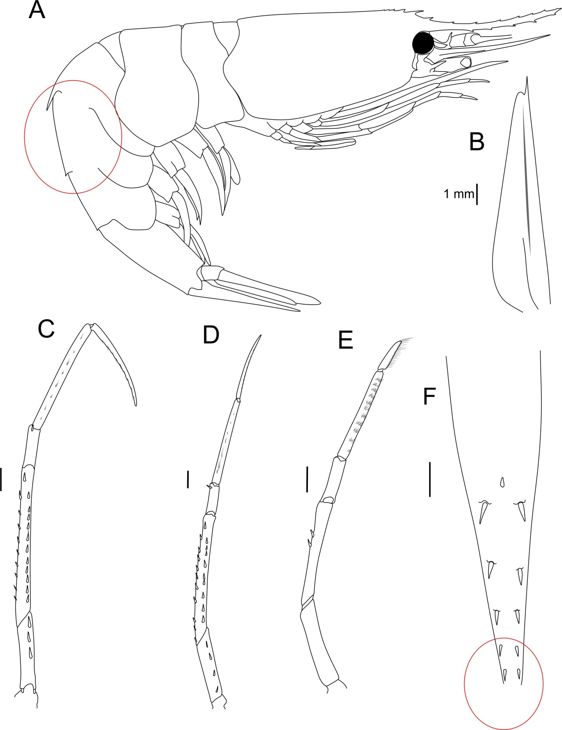

Fig.2 Yana Morphology Это не законченный вариант рисунка, Яна на днях дорисует.

Statistical analyses of morphological data and comparisons of the morphological and genetic parameters were run using R 4.0.5 (R Core Team, 2021). Missing characters (1.2% of the database) were replaced by their mean values characters (Legendre, Legendre, 2012). The juveniles (carapace lengths < 5 mm) were removed from the morphological analysis as the proportions of this species greatly change during ontogenesis.

In order to remove the influence of individual size, we used carapace length and carapace height as predictors in Redundancy analysis (RDA) (Oksanen et al., 2020) and the other 26 characters as dependent variables in the matrix. The analysis was run using the rda() function from the “vegan” package (Oksanen et al., 2020), yielding both constrained and unconstrained axes.

The canonical axes were influenced by the size of individuals, while the unconstrained axes provided insight into the structure of the residual matrix from regression models, allowing us to examine the relationship between morphological characters without the impact of size. Therefore, we excluded the canonical axes (RDA1 and RDA2) from further analysis and focused on the two most informative unconstrained axes, PCA1 and PCA2, which facilitated a more accurate analysis of morphological characters without interference from the influence of individual size.

We used the Mantel test (Legendre, Legendre, 2012) to assess the correlation between the morphological features and genetic characteristics and created two distance matrices. The first matrix included Euclidean distances between individuals in PCA1 and PCA2 space, whereas the second one included square roots of pairwise genetic distances between the sequences of the COI gene. Genetic distances were calculated using the dist.alignment() function from the “seqinr” package (Charif, Lobry, 2007). The mantel correlation between the two matrices was calculated using the mantel() function from the “vegan” package (Oksanen et al., 2020). The statistical significance of the test was assessed using the permutation method (9999 permutations). Results of the statistical analyses were visualized using the package "ggplot2" (Wickham, 2016).

Table 1. Morphological characters used and their average values for the three geographical regions. In qualitative characters, 0 means absence and 1 means presence of this morphological character. “+” - present, “-“ – absent.

|  |  |  |  |  |  |  |
| --- | --- | --- | --- | --- | --- | --- |
| **#** | **Character description** | **Abbreviation** | **Unit of Measure** | **Average for geographical Regions** | | |
| **North Atlantic** | **South Atlantic** | **Indian Ocean** |
|  | **CARAPACE** |  |  |  |  |  |
| 1 | Carapace height | CH | mm | 6.2 | 7.7 | 5.8 |
| 2 | Carapace lenght | CL | mm | 10.2 | 12.1 | 9.8 |
| 3 | Dorsal teeth | DT | n | 14.4 | 14.4 | 14.6 |
| 4 | Postorbital dorsal teeth | PDT | n | 2.6 | 2.6 | 2.8 |
| 5 | Ventral teeth | VT | n | 8.6 | 8.4 | 8.5 |
|  | **PLEON** |  |  |  |  |  |
| 6 | Third pleonic somite. Dorsal carina | Carina | 0/1 | 1.0 | 0.8 | 1.0 |
| 7 | Fourth pleon. Serrations on lateral margin-right side | 4_som_ser_right | n | 5.2 | 6.8 | 5.2 |
| 8 | Fourth pleonic serrations on lateral margin-left side | 4_som_ser_left | n | 5.0 | 6.6 | 5.2 |
| 9 | Fifth pleonic serrations on lateral margin-right side | 5_som_ser_right | n | 3.6 | 4.6 | 3.5 |
| 10 | Fifth pleonic. serrations on lateral margin-left side | 5_som_ser_left | n | 3.4 | 4.6 | 3.3 |
| 11 | Fifth pleonic somite. Sharp tooth on posterior margin of pleuron-left side | 5_pleur_tooth_l | 0/1 | 0.9 | 1.0 | 1.0 |
| 12 | Fifth pleonic somite. Sharp tooth on posterior margin of pleuron-right side | 5_pleur_tooth_r | 0/1 | 0.8 | 1.0 | 1.0 |
|  | **TELSON** |  |  |  |  |  |
| 13 | Telson. Pairs of dorsolateral spines | t_dv_spines | n | 5.4 | 5.0 | 5.0 |
| 14 | Telson. Numerous lateral spines arranged in two or more rows | t_lat_spines | 0/1 | 0.0 | 0.0 | 0.0 |
|  | **ANTENNA** |  |  |  |  |  |
| 15 | Scaphocerite. Medial dorsal groove | scaph | 0/1 | 1.0 | 1.0 | 1.0 |
|  | **PEREOPODS** |  |  |  |  |  |
| 16 | Third pereopod. Ischium. Anterior row of spines. movable spines | 3_pereopod_ischium_ant_spines | n | 0.0 | 0.0 | 0.0 |
| 17 | Third pereopod. Ischium. Posterior row of movable spines, number of spines | 3_pereopod_ischium_post_spines | n | 3.3 | 3.8 | 3.3 |
| 18 | Third pereopod. Merus. Anterior row of movable spines, number of spines | 3_pereopod_merus_ant_spines | n | 1.2 | 1.8 | 1.3 |
| 19 | Third pereopod. Merus. Posterior row of movable spines, number of spines | 3_pereopod_merus_post_spines | n | 11.8 | 12.8 | 12.4 |
| 20 | Third pereopod. Carpus. Anterior row of movable spines, number of spines | 3_pereopod_carpus _ant_spines | n | 0.0 | 0.0 | 0.0 |
| 21 | Third pereopod. Carpus. Posterior row of movable spines, number of spines | 3_pereopod_carpus _post_spines | n | 1.0 | 1.0 | 1.0 |
| 22 | Forth pereopod. Ischium. Anterior row of movable spines, number of spines | 4_pereopod_ischium_ant_spines | n | 1.1 | 1.0 | 1.4 |
| 23 | Forth pereopod. Ischium. Posterior row of movable spines, number of spines | 4_pereopod_ischium_post_spines | n | 3.5 | 4.4 | 3.6 |
| 24 | Forth pereopod. Merus. Anterior row of movable spines, number of spines | 4_pereopod_merus_ant_spines | n | 4.6 | 5.2 | 4.8 |
| 25 | Forth pereopod. Merus. Posterior row of movable spines, number of spines | 4_pereopod_merus_post_spines | n | 9.8 | 12.2 | 10.4 |
| 26 | Forth pereopod. Carpus. Anterior row of movable spines, number of spines | 4_pereopod_carpus _ant_spines | n | 0.0 | 0.2 | 0.0 |
| 27 | Forth pereopod. Carpus. Posterior row of movable spines, number of spines | 4_pereopod_carpus _post_spines | n | 1.0 | 0.8 | 1.0 |
| 28 | Fifth pereopod. Ischium. Anterior row of movable spines, number of spines | 5_pereopod_ischium_ant_spines | n | 0.4 | 0.6 | 0.5 |
| 29 | Fifth pereopod. Ischium. Posterior row of movable spines, number of spines | 5_pereopod_ischium_post_spines | n | 1.2 | 1.0 | 1.1 |
| 30 | Fifth pereopod. Merus. Anterior row of movable spines, number of spines | 5_pereopod_merus_ant_spines | n | 2.0 | 3.0 | 2.2 |
| 31 | Fifth pereopod. Merus. Posterior row of movable spines, number of spines | 5_pereopod_merus_post_spines | n | 4.3 | 4.2 | 4.3 |
| 32 | Fifth pereopod. Carpus. Anterior row of movable spines, number of spines | 5_pereopod_carpus _ant_spines | n | 1.0 | 1.0 | 1.0 |

**3. Results**

**3.1. Genetic variability and spatial structure.**

The COI gene was successfully sequenced in all 75 specimens of our collections; additional 31 sequences were mined from GenBank (Benson et al., 2012) and added to the dataset. The phylogenetic reconstruction retrieved two supported clades, the most abundant Clade 1 (1/76 - Bayesian posterior probabilities/ ML bootstrap) comprised 96% of the COI sequences (Fig. 3A). This clade included all specimens from the North and South Atlantic (68 and 6, respectively) and 27 specimens from the Indian Ocean. The sister Clade 2 did not gain bootstrap support (0.98/57) and encompassed four specimens of *S. debilis* collected off the north coast of Madagascar and one specimen of *S. liui* (KT946751) from the western Pacific.

Specimens from the Сlade 1 showed moderate haplotype diversity (Hd) of 0.547±0.059 (range: 0.611-1.000) and low nucleotide diversity (*π*) of 0.0016±0.000 (range: 0.0020-0.0056) across all three regions (Table 2). In the COI minimum-spanning network, 21 unique haplotypes were observed across 102 specimens, with 68 of these representing a shared central haplotype across all three regions (Fig. 3B). Specimens from the Clade 2 (including *S. liui*) had higher values of Hd (1.000±0.126) and *π* (0.0122±0.003) and unique haplotypes that were separated by 29 substitutions from Clade 1 haplogroup (Fig. 3B). The Tajima’s D neutrality test resulted in a rejection of the neutral model for the Clade 1 overall (*D*= -2.338, p < 0.001) and the North Atlantic population (*D*= -1.913, p < 0.05), which is typical of a recently expanded population.

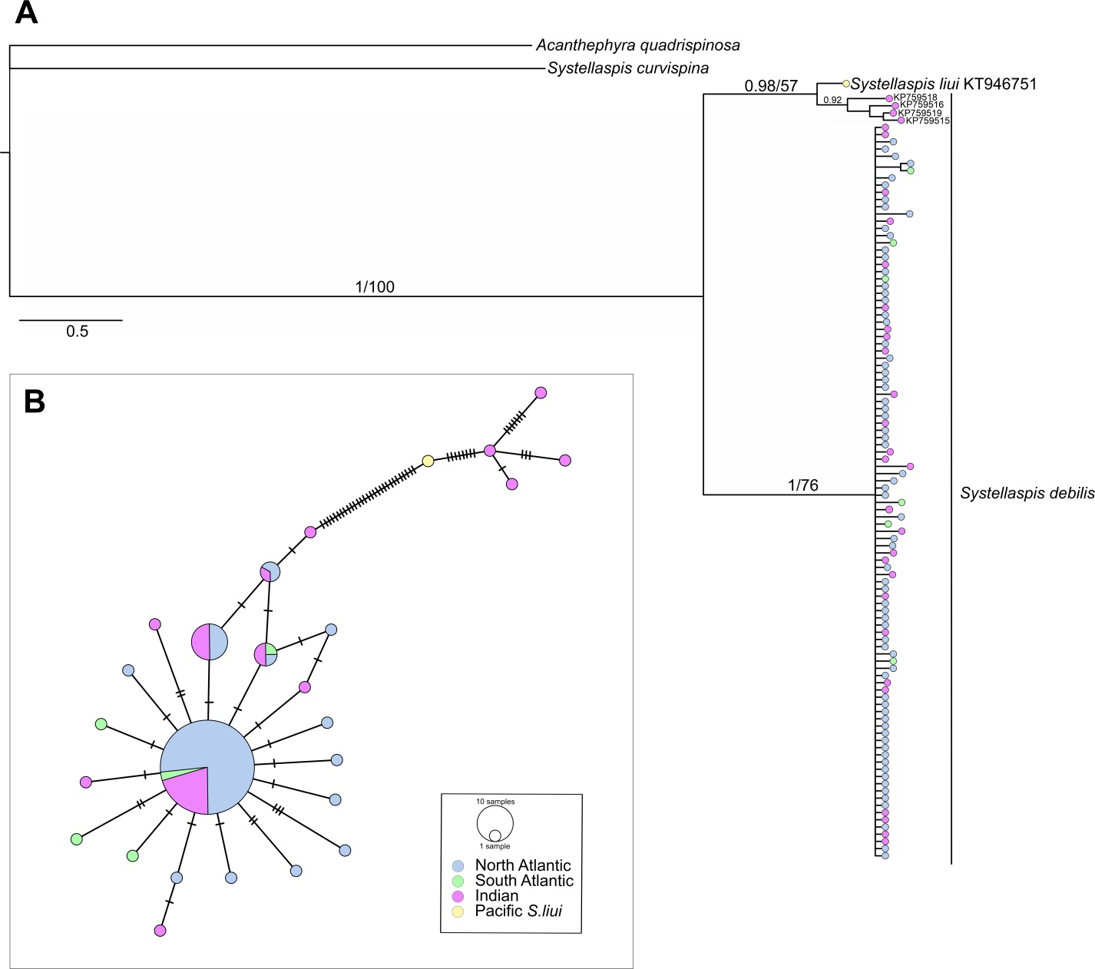

Figure 3. A. Bayesian consensus phylogram of *Systellaspis debilis* based on mitochondrial cytochrome c oxidase I (COI) gene fragment (539bp). The horizontal scale bar marks the number of expected substitutions per site. Statistical support indicated as Bayesian posterior probabilities (left) and Maximum Likelihood bootstrap values for 1000 pseudoreplicates (right). B. Minimum-spanning networks of *S. debilis* COI gene fragment. The size of the filled circles represents the number of individuals with each haplotype, with the smallest circles representing one individual with that haplotype, while colour represents sampling regions. Hatch marks on the branches represent the number of mutational steps.

Table 2. Genetic diversity of *Systellaspis debilis* for mitochondrial cytochrome c oxidase I (COI) gene including haplotype diversity (Hd), nucleotide diversity (π), and Tajima's D (D)

|  |  |  |  |  |  |
| --- | --- | --- | --- | --- | --- |
| Group | Number of specimens | Number of haplotypes | Haplotype  diversity (Hd±Sd) | Nucleotide  diversity (π±Sd) | Tajima's D |
| Clade 1 | 102 | 21 | 0.547±0.059 | 0.0016±0.000 | -2,33753** |
| North Atlantic | 69 | 15 | 0.611±0.064 | 0.0020±0.000 | -1.91338* |
| South Atlantic | 6 | 6 | 1.000±0.096 | 0.0056±0.000 | -1.42284 |
| Indian Ocean | 27 | 10 | 0.726±0.089 | 0.0027±0.001 | -1,44135 |
| Clade 2 | 5 | 5 | 1.000±0.126 | 0.0122±0.003 | -0.60926 |
| In total | 107 | 26 | 0.589±0.056 | 0.0071±0.002 | -2.05858* |

Note: Significant Tajima's D values are indicated by * (p < .05) or ** (p < .001). Clade 2 includes a single sequence of *S. liui*.

The ITS1 gene marker was analyzed in the specimens from the Clade 1, as the Clade 2 representatives were absent in our collection. We randomly sorted 5-10 specimens from each region and successfully sequenced 10 specimens from the North Atlantic, five from the South Atlantic and eight from the Indian Ocean. Genetic diversity was very low among the sequences: 19 out of 23 were identical and the others were differed in 1-12 substitutions

**3.2. Morphological variability.**

Four characters (numerous lateral spines arranged in two or more rows on the telson, presence of the medial dorsal groove on the scaphocerite, number of the movable spines on the ischium of the third pereopod (anterior row of spines), number of the movable spines on the carpus of the third pereopod (anterior row of spines) with no variance were also removed from the analysis. Overall, 28 characters of 73 specimens were used in statistical analyses.

RDA model with carapace length and height as the predictors was statistically significant (ANOVA: **F = 7.3655, p = 0.0001**). The two canonical axes described 18% of the total variance, which suggested that 82% of the morphological variance was not related to the body size and 38% of the residual variability was determined by PCA1 and PCA2.

Table 3. Partitioning of variance for morphological characters of *Systellaspis debilis* based on RDA results. The constrained axes correspond with the body size, and the unconstrained describe the characters that do not correlate with the size.

|  |  |  |  |  |
| --- | --- | --- | --- | --- |
| *Axis type* | Constrained | | Unconstrained | |
| **Axis** | **RDA1** | **RDA2** | **PC1** | **PC2** |
| **Eigenvalue** | 5.0983 | 0.2853 | 7.4947 | 3.6436 |
| **Proportion of Variance Explained** | **0.1728** | **0.0097** | **0.254** | **0.1235** |
| **Cumulative Proportion of Variance explained** | **0.1825** | | **0.3775** | |
| 0.56 | | | |

The RDA model demonstrated a positive correlation between the body size and some morphological characters (Fig. 4A) such as the number of movable spines in the posteriorrow of the ischium of the 5th pereopods and the number of serrationsonthelateralmargin of the 4th and 5thabdominal somites. Since for the correct analysis of morphological variability it was necessary to exclude the influence of size, further work was based on the analysis of the residual RDA variability; i.e., the variability of the non-canonical axes (Fig. 4B) analysis was applied to eliminate the influence of size on characters.

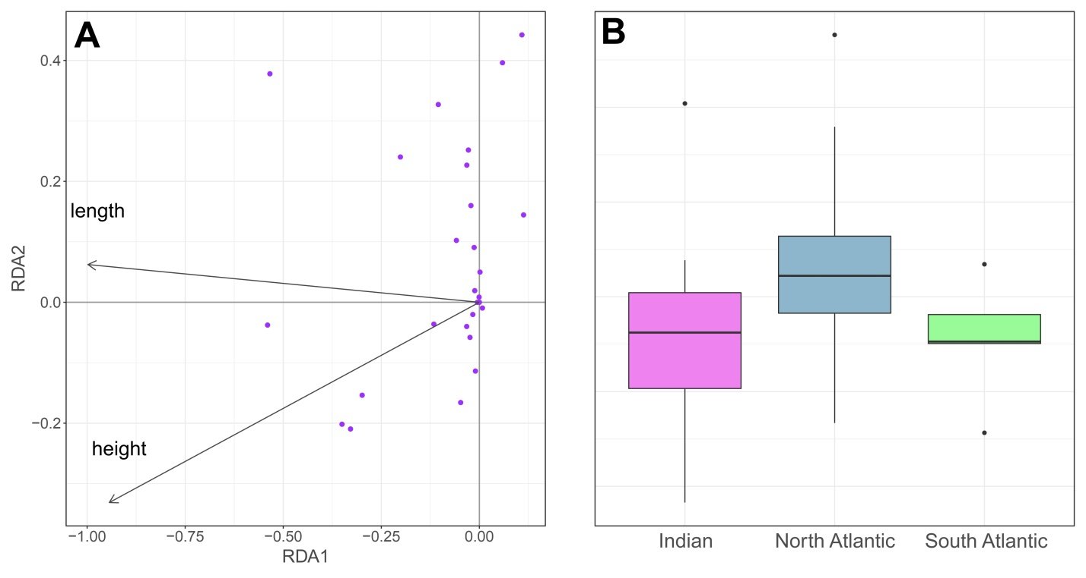Figure 4.The RDA results. A. Ordination of morphological characters in the space of canonical axes RDA1 and RDA2. B. Variability of individuals of *S. debilis* from the Indian Ocean, Northern, and Southern Atlantic along the non-canonical PC1 axis.Обозначить выбросы, 95% довер. инт и т.д. на рисунке B. Что чем обозначено

This analysis revealed a statistically significant relationship between morphological variability (the first non-canonical axis, PC1) and the sampling region (ANOVA: F = 5.306, p = 0.0073) (Fig. 4B).Specifically, specimens from the North Atlantic region exhibited lower PC1 values compared to those from the South Atlantic and the Indian Ocean. However, we did not observe any significant relationship between PC2 and the sampling location (ANOVA: F = 0.01, p = 0.99). The correlation between some morphological features indicated by PC1 and their collection locations is noteworthy (Fig. 5). The characters driving these distinctions, such as the number of spines in the posterior row on the merus of the third and anterior row of the merus of the fourth pereopod, were linked with significantly higher values in the Indian Ocean individuals than in those from other locations. Similarly, individuals from the South Atlantic had a higher average number of spines in the posterior row on the merus of the fourth pereopod than individuals from other geographic areas. Furthermore, the number of lateral serrations on the pleon on the left side of the fourth abdominal segment of the South Atlantic shrimp was only slightly higher than that of individuals from the Indian Ocean. The lowest average number of spines on the third and fourth pereopod and the number of teeth on the left side of the fourth pleonic somite were observed in the North Atlantic group, further emphasizing the differences in morphology across geographic regions.

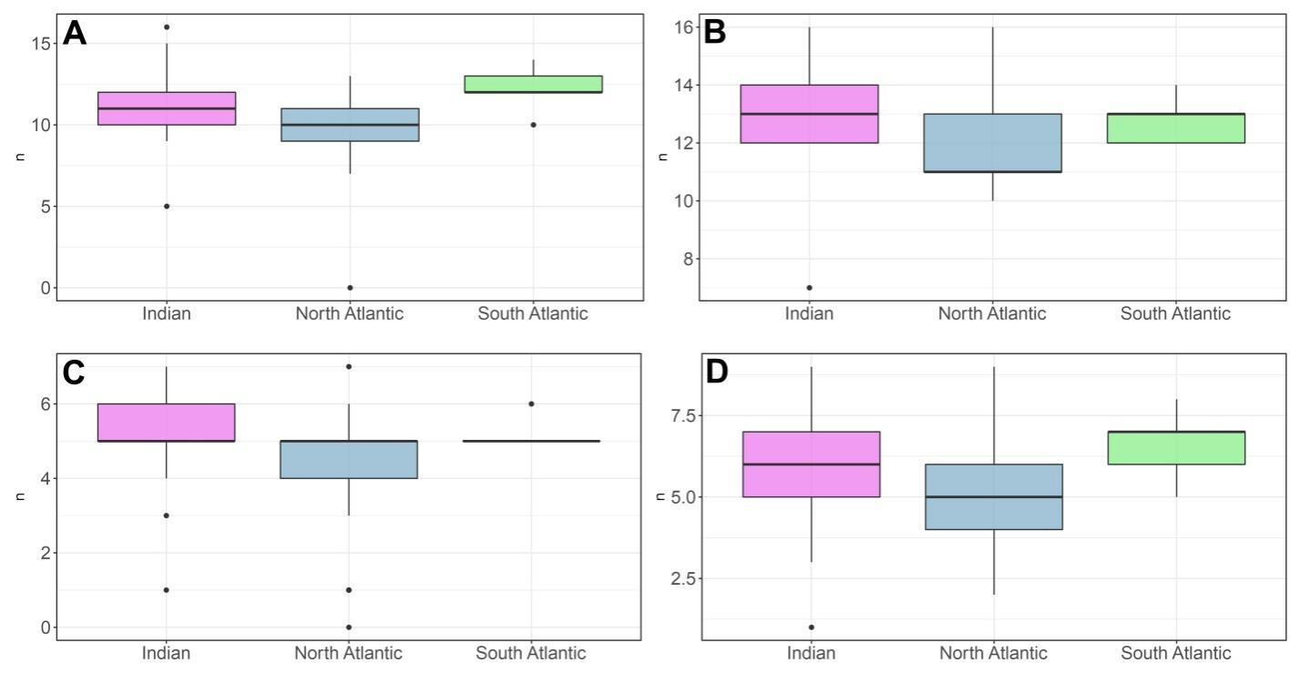Figure 5. Variance of the key morphological characters between populations from the Indian Ocean (21 specimens), Northern (43), and Southern (5) Atlantic: A. Number of spines in the posterior row on the merus of the 4th pereopods, B. Number of spines in the posterior row on the merus of the 3rd pereopods, C. Number of spines in the posterior row on the merus of the 4th pereopods, D. Serrations on the lateral margin of the 4th abdominal somite, right side.

In order to analyze the relationship between the genetic and morphological characters of individuals, we ran the Mantel test that assessed the similarity of the two distance matrixes (genetic distance matrix and distance matrix in the space of PC1 and PC2 ~~of the first two non-canonical axes~~). The results of this test showed that there is a statistically significant similarity between the two matrixes (r = 0.1791, p = 0.003, 9999 permutations). Thus, it was observed a correlation between the genetic and morphological characters of specimens.

Всё хорошо, только для ясности надо нарисовать схему. Три блока (NA,SA, IO), и чем каждый из них статистически достоверно отличается от других (например стрелками)

А стрелками – чем отличается и насколько. Ну или по-другому. Самим станет понятнее.

**4. Discussion**

**4.1 Population structure of *Systellaspis debilis* (Clade 1)**

Our phylogeographic survey of the circumtropical mesopelagic shrimp *Systellaspis debilis* reveals two divergent and monophyletic mitochondrial clades with different geographic distribution. All specimens in our collections fell into the Clade 1. Since only representatives of this clade were found near the type locality of the species (Bahamas Channel, North Atlantic) and their species identity was confirmed morphologically, we consider this clade as *S. debilis*. We found no genetic differentiation between populations of *S. debilis* (i.e., the Clade1) in the North Atlantic, the South Atlantic, and the Indian Oceans. The genetic similarity of the COI and ITS1 genes could be the result of several scenarios.

Firstly, this is intensive gene flow through ecological barriers that usually impede gene flow between populations of mesoplankton (Goetze 2005, 2011; Miyamoto et al., 2010; Blanco-Bercial et al., 2011; Burridge et al., 2015; Kulagin et al., 2017; 2021; Choo et al., 2021). These mesoplankton species, even having haplotypes with circumglobal distribution, show significant variations of haplotype frequencies between oceans or ecoregions (Goetze 2005; Eberl et al., 2007; Norton and Goetze, 2013; Hirai et al., 2015; Goetze et al., 2017). In contrast to most mesoplankton, *S. debilis* is a macroplankton species undertaking intensive diurnal vertical migrations through vertical abiotic gradients (Roe, 1984), which make the species resistant to horizontal gradients of the frontal zones. In addition, a long life cycle (5–8years for oplophoroid shrimps: Omori, 1974) provides a better opportunity of the individual transfer through geographic regions with oceanic flows and thus also contribute to high levels of gene flow in *S. debilis*.

Another possible scenario suggests that barriers to gene flow do currently exist but were established not long ago enough to provide genetic differentiation of *S. debilis*. In this case, purifying selection is effective in eliminating even slightly disadvantageous mutations and maintaining genetic homogeneity in each of distant populations (Nei, 1987; Hughes, 2005). In fact, the purifying selection was thought to be a constraint on genetic diversity and differentiation between two distant populations of this species in the North-West Atlantic (Timm et al., 2020). Subtle or no genetic differentiation at the global (circumtropical) scale was also reported for some large pelagic fishes and explained by the large effective size of their populations and (or) high capacity for dispersion, which can obscure signals of spatial genetic differentiation (Ely et al., 2005; Hoelzel et al., 2006; Haro‐Bilbao et al., 2021).

The second scenario is supported by the star-like structure of haplotype network, the lack of transversion mutations and the negative and significant Tajima’s D values. In fact, the low haplotype diversity of *S. debilis* is unusual for a globally distributed zooplankton species (a similar effect was found only in few species with much more limited distribution: the northern krill *Meganyctiphanes norvegica* (Papetti et al., 2005) and the neritic chaetognath *Sagitta setosa* (Peijnenburg et al., 2006)). Despite their large population size, marine pelagic species may be susceptible to population crashes with measurable effects on their genetic makeup. Bottlenecks resulting from range contractions during the Pleistocene were proposed to have occurred in two copepod and one chaetognath species in the North Atlantic which display lower levels of genetic variation than expected from their estimated population sizes (Bucklin and Wiebe, 1998; Peijnenburg et al., 2005), *S. debilis* may have emerged relatively recently and spread over a huge area due to the possession of some evolutionary/ecological advantage. As there are no fossil records for *S. debilis* or related species, no correlation can now be found with any specific event in the past.

Although the dispersal of *S. debilis* between oceans could have taken place in either direction, the 'Indian to Atlantic' route seems more likely to us.Of the eleven currently recognized species of the genus *Systellaspis*, ten occur in the Pacific Ocean, seven in the Indian Ocean, and only six in the Atlantic Ocean (Table 4), suggesting that the center of biodiversity seems to have been the Pacific Ocean. Furthermore, no species endemic to the Atlantic Ocean are noted, supporting the idea that dispersal of *S. debilis* s.s. originated from the Pacific Ocean and the species gradually colonised the Indian and Atlantic Oceans.

Two hypotheses on the direction of dispersal of *S. debilis* s.s. are considered. One hypothesis suggests that the colonization pathway from the Indian to the Atlantic Ocean through the equatorial waters was restricted in the West direction after the collision of Africa and Eurasia around 13 million years ago, and in the East direction by the separation of the Atlantic from the eastern Pacific by the rise of the Isthmus of Panama around 3.5 million years ago (Bowen et al., 2016). The alternative pathway in the East direction through the Drake Passage is characterized by low temperatures, which would be an obstacle to the settlement of warm-water shrimp. The hypothesis of the modern or recent species' colonization route through the waters off South Africa is consistent with the fact that where the Agulhas Current turns back on itself, eddies can periodically spin off (known as Agulhas Rings) and are advected northward in the Benguela Current (Hutchings et al., 2009). This mechanism is proposed for some benthic and pelagic organisms (Lessios et al. 2001; Ely et al., 2005; Dudoit et al., 2018; Haro‐Bilbao et al., 2021).

*Table 4.: Systellaspis Species in the Atlantic, Indian, and Pacific Oceans (based on <https://obis.org/taxon/107027>)*

|  |  |  |  |
| --- | --- | --- | --- |
| **Species / Ocean** | **Atlantic** | **Indian** | **Pacific** |
| *Systellaspis braueri* (Balss, 1914) | 1 |  | 1 |
| *Systellaspis cristata* (Faxon, 1893) | 1 | 1 | 1 |
| *Systellaspis curvispina* Crosnier, 1988 | 1 | 1 | 1 |
| *Systellaspis debilis* (A.Milne-Edwards, 1881) | 1 | 1 | 1 |
| *Systellaspis eltanini* Wasmer, 1986 | 1 | 1 |  |
| *Systellaspis guillei* Crosnier, 1988 |  | 1 | 1 |
| *Systellaspis intermedia* Crosnier, 1988 |  | 1 | 1 |
| *Systellaspis lanceocaudata* Spence Bate, 1888 |  |  | 1 |
| *Systellaspis liui* Sha & Wang, 2015 |  |  | 1 |
| *Systellaspis paucispinosa* Crosnier, 1988 |  |  | 1 |
| *Systellaspis pellucida* (Filhol, 1884) | 1 | 1 | 1 |
| **Total species number** | **6** | **7** | **10** |

In the Indian Ocean, most of *S. debilis* specimens were collected between 20° S and 34° S within the Southern Indian Ocean and Agulhas Current mesopelagic ecoregions according to Sutton et al. (2017). Only one specimen from GenBank was collected at ~13° S, northwest of Madagascar, in the Mid-Indian Ocean ecoregion. Surprisingly, the same site harbored four genetically different specimens, which, along with *S. liui* from the West Pacific, composed the Clade 2. As no specimens of Сlade 2 were found in the Atlantic Ocean and south of 20° S in the Indian Ocean, we suggest that the geographic boundary between the both clade occur between 13° S and 20° S in the Indian Ocean. This is consistent with the boundary between (Sutton et al., 2017; Reygondeau et al, 2018).

**4.2. Morphological variability of *Systellaspis debilis* (Clade 1).**

Our analyses showed that specimens from the North Atlantic had lower average PC1 values than those from the South Atlantic and Indian Oceans (Fig XX) and suggested significant morphological differences between shrimp populations in these regions. In particular, , the number of spines in the posterior row on the merus of the third and anterior row of the merus of the fourth pereopod, were significantly higher in individuals collected from the Indian Ocean. Individuals from the South Atlantic, on the other hand, had a higher average number of spines in the posterior row on the merus of the fourth pereopod than individuals from other geographic groups. Finally, the lowest average number of spines on the third and fourth pereopod and the number of teeth on the left side of the fourth segment were observed in the North Atlantic group, highlighting the differences in morphology across geographic regions.

Crosnier (1989) found variations in the rostrum-carapace length of *S. debilis* specimens from different geographic locations including Northern and Southern Madagascar, Northern and Southern Atlantic, and the Philippines. Our results indicated that the Lr/Lc rate of specimens from the Northern Atlantic was less homogeneous compared to those from the Indian Ocean, which could potentially be correlated with their haplotype. These findings support the notion of genetic and morphological variation among *S. debilis* populations across different regions.

The observed morphological differences between populations might be influenced by a combination of genetic and environmental factors. The Mantel test suggests that there is a significant similarity between genetic and spatial distance matrices, indicating that the observed morphological variability is likely to be driven, at least in part, by genetic differences between populations. The results suggest a link between the genetic makeup of individuals and their morphology; the exact mechanisms driving this correlation remain unclear and warrant further investigation.

The correlation between genetic and morphological traits does not necessarily imply a direct causal relationship. Other factors, such as environmental conditions and developmental plasticity, could also play a role in shaping the observed morphological variability (Burridge et al., 2019). Future studies that incorporate environmental and developmental factors will be necessary to fully understand the complexity of the relationship between genetic and morphological traits in this species of shrimp.

**4.3. The status of *Systellaspis liui* and related specimens (Clade 2).**

The Clade 2 encompassed four specimens deposited in GenBank as ‘*Systellaspis debilis’* (Aznar-Cormano et al., 2015) and one specimen of *S. liui* (Sha and Wang, 2015); Sha and Wang (2015) suggested that four specimens of ‘*S. debilis’* of Aznar-Cormano et al. (2015) and *S. liui* are synonyms. *Systellaspis liui* was described on the basis of a single female specimen from the Western Pacific (Philippine Sea) (Sha and Wang, 2015). The unique ecological trait of this species is its ability to survive at a depth beyond the usual range of the *Systellaspis* genus. According to the original description, genetic and morphological differences between *S. debilis* and *S. liui* were sufficient to erect the new species but, the validity of *S. liui* was considered as controversial (Lunina, Kulagin, and Vereshchaka, 2018). In fact, morphological variations in *S. debilis* from various locations (Crosnier, 1987; Sha and Wang, 2015) make diagnosing both species difficult.

Sha and Wang (2015) proposed four morphological characters to distinguish *S. liui* from *S. debilis.* Our morphological analysis showed that three of them present in 26-100% of observed *S. debilis*: a medial dorsal groove on the scaphocerite, a carina on the dorsal margin of the third abdominal somite, movable spines on the pereopods, and three teeth on the posterior margin of the fifth abdominal somite The only morphological character not found in our specimens of *S. debilis* is the presence of additional spines on the telson, the character not common for the family Oplophoridae and likely attributed to an abnormal specimen (Lunina et al., 2019).

Molecular evidence to erect the new species *S. liui* was based on COI sequence divergence (K2P) of more than 5%, between *S. liui* and *S. debilis* (Sha and Wang, 2015). For decapods, within-species COI sequence divergences range from 0.24 to 1.8% ([Iacchei et al., 2016](https://doi.org/10.1111%2Fjbi.12689); [Ketmaier, Argano & Caccone, 2003](https://doi.org/10.1046%2Fj.1365-294X.2003.01734.x); [Knowlton & Weigt, 1998](https://doi.org/10.1098%2Frspb.1998.0568); [Matzen da Silva et al., 2011](https://doi.org/10.1371%2Fjournal.pone.0019449); [Morrison, Ríos & Duffy, 2004](https://doi.org/10.1016%2FS1055-7903%2803%2900252-5); Quan et al., 2004) whereas divergence among species within a genus is typically higher (2.4%–32.7%; [Matzen da Silva et al., 2011](https://doi.org/10.1371%2Fjournal.pone.0019449); Dudoit et al., 2018; Vereshchaka et al., 2022). Here we compared interspecific and intraspecific K2P distances for all species of the genus *Systellaspis*, our *S. debilis* (Clade 1), the Clade 2, and *S. liui.* The Clade 2 (with and without *S. liui*)andthe Clade 1 had a distance of 7.1%, which was the lowest observed pairwise distance (8.0-32.5%) (Supplementary Table SX). A comparable divergence (8.0 %) was observed between *Systellaspis braueri* and *Systellaspis paucispinosa*, which also differ mainly in the spination of the telson. Pairwise differences within the both clades were rather low (0.3 % and 1.2%) and matched those for *Systellaspis curvispina* (Supplementary Table SX). Much higher intraspecific values (8.2-12.5%) were observed in three other *Systellaspis* species (*S. braueri*, *S. cristata* and *S. pellucida*), which suggests the presence of cryptic species (Supplementary Table SX). Overall, observed divergences in COI sequences within and between the Clade 1 and Clade 2 of *S. debilis* suggest that *S. liui* is similar to ‘*S. debilis’* of Aznar-Cormano et al. (2015) and both represent a separate mitochondrial clade. However, additional material for morphological studies and additional nuclear genes analyses are required to clarify taxonomic status of *S. liui* and ‘*S. debilis’* of Aznar-Cormano et al. (2015).

Table SX. Intra- and intergroup genetic distances of COI gene of *Systellaspis* species and clades. "*Systellaspis debilis* Clade 1" corresponds to specimens from the Atlantic and Southern Indian Ocean, "*S. debilis* Clade 2 (Ind.)" corresponds Clade 2. Intragroup distances are marked in blue.

|  |  |  |  |  |  |  |  |  |  |  |
| --- | --- | --- | --- | --- | --- | --- | --- | --- | --- | --- |
|  | *S. braueri* | *S. cristata* | *S. curvispina* | *S. debilis* Clade 1 | *S. debilis* Clade 2 without *S. liui* | *S. debilis* Clade 2 with *S. liui* | *S. guillei* | *S.*  *liui* | *S. paucispinosa* | *S. pellucida* |
| *S. braueri* | 0.125 |  |  |  |  |  |  |  |  |  |
| *S. cristata* | 0.231 | 0.113 |  |  |  |  |  |  |  |  |
| *S. curvispina* | 0.240 | 0.130 | 0.004 |  |  |  |  |  |  |  |
| *S. debilis* Clade 1 | 0.317 | 0.305 | 0.291 | 0.003 |  |  |  |  |  |  |
| *S. debilis* Clade 2 without *S. liui* | 0.312 | 0.300 | 0.281 | 0.071 | 0.010 |  |  |  |  |  |
| *S. debilis* Clade 2 with *S. liui* | 0.313 | 0.300 | 0.281 | 0.071 | NA | 0.012 |  |  |  |  |
| *S. guillei* | 0.242 | 0.226 | 0.221 | 0.325 | 0.300 | 0.300 | NA |  |  |  |
| *S. liui* | 0.315 | 0.300 | 0.283 | 0.068 | 0.017 | NA | 0.300 | NA |  |  |
| *S. paucispinosa* | 0.080 | 0.217 | 0.230 | 0.299 | 0.298 | 0.299 | 0.238 | 0.302 | NA |  |
| *S. pellucida* | 0.240 | 0.191 | 0.197 | 0.298 | 0.286 | 0.288 | 0.219 | 0.295 | 0.225 | 0.082 |

**Conclusions**

Our data indicate that *S. debilis* is a genetically cohesive species throughout its distribution range in the whole Atlantic and the Southwest Indian Ocean. Populations of *S. debilis* are genetically homogenous in three geographically distant ocean basins separated by oceanographic fronts, which is unusual for plankton species studied thus far. In contrast to genetic homogeneity, statistically significant morphological differences do present and populations from the North Atlantic, South Atlantic, and Southwest Indian Oceans differ in spination of pereopods and serration of pleonic somites. Scenarios to explain the observed phenomenon include intensive gene flow through ecological barriers owing to resistance to horizontal oceanographic gradients and long life cycle and/or purifying selection of mitochondrial genes. In both cases morphological variation between regions may be the result of phenotypic plasticity or have a genetic (not mitochondrial-linked) basis. The use of genomic approaches will clarify this question and unveil finer population structure and possible local adaptation of the species, as was shown for some other pelagic organisms (DeHart et al., 2020; Haro-Bilbao et al., 2021). We encourage marine biologist towards further study of the population structure of mesopelagic shrimps as a key component of deep-sea communities and a target for possible commercial exploitation.

*Systellaspis debilis* is similar to five specimens including *S. liui* that creates a separate clade distributed in the West Indian Ocean and the West Pacific. Both clades are parapatric, and geographic boundary occurs between 13° S and 20° S in the Indian Ocean. The taxonomic status of the ‘*S. liui’* clade (species, subspecies, species complex) needs further clarification through additional material for morphological studies and additional nuclear genes analyses.

Add to References

Mackas, D. L., & Beaugrand, G. (2010). Comparisons of zooplankton time series. Journal of Marine Systems, 79(3-4), 286-304.

Sutton, T. T., … Vereshchaka A.L., ... & Haedrich, R. L., 2017. A global biogeographic classification of the mesopelagic zone. Deep Sea Research Part I: Oceanographic Research Papers, 126: 85-102.

A. L. Vereshchaka, A. S. Mikaelyan, S. A. Piontkovski, A. A. Lunina (2023). A mesoplankton biomass decline in the Central Atlantic coupled with an increase of surface temperature and an expansion of low-productive zones. Global Ecology and Biogeography, DOI: 10.1111/geb.13703.

Mengerink, K.J., Van Dover, C.L., Ardron, J., Baker, M., Escobar-Briones, E., Gjerde, K., Koslow, J.A., Ramirez-Llodra, E., Lara-Lopez, A., Squires, D., Sutton, T.T., Sweetman, A.K., Levin, L.A., 2014. A call for deep-ocean stewardship. Science 344, 696–698.

Eberl, R., Cohen, S., Cipriano, F., & Carpenter, E. J. (2007). Genetic diversity of the pelagic harpacticoid copepod Macrosetella gracilis on colonies of the cyanobacterium Trichodesmium spp. Aquatic Biology, 1(1), 33-43.

Goetze, E. (2005). Global populatiion genetic structure and biogeography of the oceanic copepods Eucalanus hyalinus and E. spinifer. Evolution, 59(11), 2378-2398.

Goetze, E. (2011). Population differentiation in the open sea: insights from the pelagic copepod *Pleuromamma xiphias*. Integrative and comparative biology, 51(4), 580-597.

Burridge, A. K., Goetze, E., Raes, N., Huisman, J., & Peijnenburg, K. T. (2015). Global biogeography and evolution of Cuvierina pteropods. *BMC Evolutionary Biology*, *15*(1), 1-16.

Hirai, J., Tsuda, A., & Goetze, E. (2015). Extensive genetic diversity and endemism across the global range of the oceanic copepod Pleuromamma abdominalis. *Progress in Oceanography*, *138*, 77-90.

Norton, E. L., and Goetze, E. 2013. Equatorial dispersal barriers and limited population connectivity among oceans in a planktonic copepod. Limnology and Oceanography, 58: 1581–1596. Wiley. <http://dx.doi.org/10.4319/lo.2013.58.5.1581>.

Peijnenburg, K. T. C. A., C. Fauvelot, J. A. J. Breeuwer, and S. B. J. Menken. 2006. Spatial and temporal genetic structure of the planktonic *Sagitta setosa* (Chaetognatha) in European seas as revealed by mitochondrial and nuclear DNA markers. Mol. Ecol. 15:3319–3338.

Papetti, C., Zane, L., Bortolotto, E., Bucklin, A., & Patarnello, T. (2005). Genetic differentiation and local temporal stability of population structure in the euphausiid Meganyctiphanes norvegica. *Marine Ecology Progress Series*, *289*, 225-235.

Nei, M. 1987. Molecular Evolutionary Genetics. Columbia University Press, New York.

Hughes, A. L. 2005. Evidence for abundant slightly deleterious polymorphisms in bacterial populations. Genetics, 169: 533–538.

Bucklin, A., Questel, J. M., Blanco-Bercial, L., Frenzel, A., Smolenack, S. B., & Wiebe, P. H. (2021). Population connectivity of the euphausiid, Stylocheiron elongatum, in the Gulf Stream (NW Atlantic Ocean) in relation to COI barcode diversity of Stylocheiron species. *ICES Journal of Marine Science*, *78*(9), 3464-3476.

Peijnenburg, K. T. C. A., Breeuwer, J. A. J., Pierrot-Bults, A. C., & Menken, S. B. J. (2004). Phylogeography of the planktonic chaetognath Sagitta setosa reveals isolation in European seas. Evolution, 58(7), 1472–1487. <https://doi.org/10.1111/j.0014-3820.2004.tb017 28.x>

Bucklin, A., & Wiebe, P. H. (1998). Low mitochondrial diversity and small effective population sizes of the copepods Calanus finmarchicus and Nannocalanus minor: possible impact of climatic variation during recent glaciation. *Journal of heredity*, *89*(5), 383-392.

Peijnenburg, K. T. C. A., Van Haastrecht, E. K., & Fauvelot, C. (2005). Present-day genetic composition suggests contrasting demographic histories of two dominant chaetognaths of the North-East Atlantic, *Sagitta elegans* and *S. setosa*. *Marine biology*, *147*, 1279-1289.

Haro‐Bilbao, I., Riginos, C., Baldwin, J. D., Zischke, M., Tibbetts, I. R., & Thia, J. A. (2021). Global connections with some genomic differentiation occur between Indo‐Pacific and Atlantic Ocean wahoo, a large circumtropical pelagic fish. *Journal of Biogeography*, *48*(8), 2053-2067.

Ely, B., Vinas, J., Alvarado Bremer, J. et al. (2005) Consequences of the historical demography on the global population structure of two highly migratory cosmopolitan marine fishes: the yellowfin tuna (*Thunnus albacares*) and the skipjack tuna (*Katsuwonus pelamis*). BMC Evolutionary Biology 5, 19

Hoelzel, A.R., Shivji, M.S., Magnussen, J. and Francis, M.P. (2006) Low worldwide genetic diversity in the basking shark (*Cetorhinus maximus*). Biology Letters 2, 639–642.

Roe, H. S. J. (1984). The diel migrations and distributions within a mesopelagic community in the north east Atlantic. 2. Vertical migrations and feeding of mysids and decapod crustacea. *Progress in Oceanography*, *13*(3-4), 269-318.

Omori M (1974) The biology of pelagic shrimps in the ocean. AdvMarBiol 12:233–324

Lessios, H. A., Kessing, B. D., & Pearse, J. S. (2001). Population structure and speciation in tropical seas: global phylogeography of the sea urchin *Diadema*. *Evolution*, *55*(5), 955-975.

Dudoit, A. A., Iacchei, M., Coleman, R. R., Gaither, M. R., Browne, W. E., Bowen, B. W., & Toonen, R. J. (2018). The little shrimp that could: phylogeography of the circumtropical Stenopus hispidus (Crustacea: Decapoda), reveals divergent Atlantic and Pacific lineages. *PeerJ*, *6*, e4409.

Vereshchaka, A., Kulagin, D., & Lunina, A. (2022). Discovery of a New Species Provides a Deeper Insight into Taxonomic Grouping of the Deep-Sea Genus Acanthephyra (Crustacea: Decapoda). *Diversity*, *14*(11), 907.

Iacchei, M., Gaither, M. R., Bowen, B. W., & Toonen, R. J. (2016). Testing dispersal limits in the sea: Range‐wide phylogeography of the pronghorn spiny lobster Panulirus penicillatus. *Journal of Biogeography*, *43*(5), 1032-1044.

Ketmaier, V., Argano, R., & Caccone, A. (2003). Phylogeography and molecular rates of subterranean aquatic stenasellid isopods with a peri‐Tyrrhenian distribution. *Molecular Ecology*, *12*(2), 547-555.

Knowlton, N., & Weigt, L. A. (1998). New dates and new rates for divergence across the Isthmus of Panama. *Proceedings of the Royal Society of London. Series B: Biological Sciences*, *265*(1412), 2257-2263.

Matzen da Silva, J., Creer, S., Dos Santos, A., Costa, A. C., Cunha, M. R., Costa, F. O., & Carvalho, G. R. (2011). Systematic and evolutionary insights derived from mtDNA COI barcode diversity in the Decapoda (Crustacea: Malacostraca). *PLoS one*, *6*(5), e19449.

Morrison, C. L., Rios, R., & Duffy, J. E. (2004). Phylogenetic evidence for an ancient rapid radiation of Caribbean sponge-dwelling snapping shrimps (Synalpheus). *Molecular phylogenetics and evolution*, *30*(3), 563-581.

Quan, J., Zhuang, Z., Deng, J., Dai, J., & Zhang, Y. P. (2004). Phylogenetic relationships of 12 Penaeoidea shrimp species deduced from mitochondrial DNA sequences. *Biochemical Genetics*, *42*, 331-345.

DeHart, H. M., Blanco-Bercial, L., Passacantando, M., Questel, J. M., & Bucklin, A. (2020). Pathways of pelagic connectivity*: Eukrohnia hamata* (Chaetognatha) in the Arctic Ocean. *Frontiers in Marine Science*, *7*, 396.

References

Palumbi, S. R. (1994). Genetic divergence, reproductive isolation, and marine speciation. *Annual review of ecology and systematics*, *25*(1), 547-572.

Goetze, E., Hüdepohl, P. T., Chang, C., Van Woudenberg, L., Iacchei, M., & Peijnenburg, K. T. C. A. (2017). Ecological dispersal barrier across the equatorial Atlantic in a migratory planktonic copepod. Progress in Oceanography, 158, 203–212. <https://doi.org/10.1016/j.pocean.2016.07.001>

Peijnenburg, K. T. C. A., Breeuwer, J. A. J., Pierrot-Bults, A. C., & Menken, S. B. J. (2004). Phylogeography of the planktonic chaetognath Sagitta setosa reveals isolation in European seas. Evolution, 58(7), 1472–1487. https://doi.org/10.1111/j.0014-3820.2004.tb017 28.x

Churchill, C. K. C., Valdés, Á., and Ó Foighil, D. 2014. Afro-Eurasia and the Americas present barriers to gene flow for the cosmopolitan neustonic nudibranch Glaucus atlanticus. Marine Biology, 161: 899–910. <http://dx.doi.org/10.1007/s00227-014-2389-7>.

Blanco-Bercial, L., Álvarez-Marqués, F., and Bucklin, A. 2011. Comparative phylogeography and connectivity of sibling species of the marine copepod Clausocalanus (Calanoida). Journal of Experimental Marine Biology and Ecology, 404: 108–115. <http://dx.doi.org/10.1016/j.jembe.2011.05.011>.

Yebra, L., Bonnet, D., Harris, R., Lindeque, P., and Peijnenburg, K. 2011. Barriers in the pelagic: population structuring of Calanus helgolandicus and C. euxinus in European waters. Marine Ecology Progress Series, 428: 135–149. <http://dx.doi.org/10.3354/meps09056>.

Miyamoto, H., Machida, R. J., and Nishida, S. 2010. Genetic diversity and cryptic speciation of the deep sea chaetognath Caecosagitta macrocephala (Fowler, 1904). Deep Sea Research Part II: Topical Studies in Oceanography, 57: 2211–2219. <http://dx.doi.org/10.1016/j.dsr2.2010.09.023>.

Kulagin, D. N., Lunina, A. A., Simakova, U. V., & Vereshchaka, A. L. (2021). Progressing diversification and biogeography of the mesopelagic Nematoscelis (Crustacea: euphausiacea) in the Atlantic. ICES Journal of Marine Science, 78(9), 3457-3463.

Timm, L. E., Isma, L. M., Johnston, M. W., & Bracken-Grissom, H. D. (2020). Comparative population genomics and biophysical modeling of shrimp migration in the Gulf of Mexico reveals current-mediated connectivity. Frontiers in Marine Science, 7, 19.

Burridge, A. K., Goetze, E., Raes, N., Huisman, J., & Peijnenburg, K. T. (2015). Global biogeography and evolution of Cuvierina pteropods. BMC Evolutionary Biology, 15(1), 1-16.

Benson, D.A, Karsch-Mizrachi, I., Clark, K., Lipman, D.J., Ostell, J., &, Sayers, E.W. (2011). GenBank. Nucleic Acids Research, 40, D48–D53. https://doi.org/10.1093/nar/gks1195